**Climate-ready fisheries management in the California Dungeness crab fishery**

### Abstract

Fishers and fisheries managers are confronting a growing number of challenges under climate change. Important but often overlooked are challenges unrelated to shifts in distribution or productivity. These challenges include increasing fishery closures due to climate-driven increases in the frequency of harmful algal blooms and the incidental mortality of protected species. The California Dungeness crab (*Metacarcinus magister*) fishery presents a useful case study for developing and testing solutions to this emerging category of climate change challenge: it is the most economically important fishery in California waters and shifts in distribution and abundance are of secondary importance to recent closures to the fishery resulting from harmful algal blooms and whale entanglements. Here, we use a management strategy evaluation (MSE) model to evaluate the performance of alternative management options under historical oceanographic conditions and potential oceanographic futures.

**Keywords:** climate change, fisheries management, Harmful Algal Blooms, domoic acid, whale entanglement, Dungeness crab, management strategy evaluation

### 1. Introduction

Climate change is altering the ability for marine fisheries to provide food and income for people around the world [(IPCC, 2019)](https://www.zotero.org/google-docs/?W390tz). These changes are commonly viewed as occurring through impacts on either the distribution of fish stocks, i.e., where fish can be caught, or on the productivity of fish stocks, i.e., how much fish can be caught. Fish shift distributions to track their preferred temperatures [(Poloczanska et al., 2013)](https://www.zotero.org/google-docs/?Vwkik8) which can alter who has access to fisheries and who has the responsibility to manage them [(Pinsky et al., 2018)](https://www.zotero.org/google-docs/?G6nlxg). Environmentally-driven changes in growth, mortality, or recruitment rates can alter the productivity of fish stocks, as can changes in disease, habitat, or range size [(Weatherdon et al., 2016)](https://www.zotero.org/google-docs/?gWbSXm). Although changes in the distribution and productivity of stocks can often increase catch potential [(Free et al., 2019; Lotze et al., 2019)](https://www.zotero.org/google-docs/?uXIM0p), non-stationary population dynamics nearly always complicate fisheries stock assessment and management procedures, and can increase the risk of suboptimal resource use [(Szuwalski and Hollowed, 2016)](https://www.zotero.org/google-docs/?ylH6vu). In general, adaptations to these changes will require accounting for shifts in productivity and distribution in stock assessments and the determination and allocation of catch limits and ensuring that management does not degrade as stocks shift into new jurisdictions [(Gaines et al., 2018; Karp et al., 2019; Pinsky and Mantua, 2014)](https://www.zotero.org/google-docs/?D9wnfL).

Climate change is also altering catch potential through processes unrelated to shifts in productivity or distribution. These impacts are often overlooked because they do not directly affect the risk of suboptimal fishing but are important because they can still restrict the availability or profitability of catch to fishers. For example, climate change is increasing the frequency, duration, and toxicity of Harmful Algal Blooms (HABs; [(Gobler et al., 2017; IPCC, 2019; McKibben et al., 2017)](https://www.zotero.org/google-docs/?PrRNSp)), which produce toxic phytoplankton that contaminate seafood, present a public health risk, and can result in the closure of commercially important fisheries [(Dyson and Huppert, 2010; Grattan et al., 2016; Lewitus et al., 2012)](https://www.zotero.org/google-docs/?jT8DiE). Similarly, climate change can increase the likelihood of bycatch of non-target or protected species by increasing the overlap between fishing grounds for target species and foraging grounds for bycatch species [(Hobday et al., 2015)](https://www.zotero.org/google-docs/?IkNLsm). This can result in reduced efficiency and profitability in the case of non-target catch [(Dunn et al., 2016)](https://www.zotero.org/google-docs/?PJjx6e) or in the closure of the fishery in the case of protected species [(Patrick and Benaka, 2013)](https://www.zotero.org/google-docs/?xRn5Du). Finally, climate change is increasing the prevalence of marine diseases, some of which (e.g., *Ichthyophous*) can reduce the market value of seafood without compromising the growth or mortality of the organism [(Burge et al., 2014)](https://www.zotero.org/google-docs/?PflC3l). Management strategies for addressing these processes would be distinct from those aimed at climate-driven shifts in productivity and distribution.

The California Dungeness crab (*Metacarcinus magister*) fishery presents a useful case study for developing and testing solutions to this emerging category of climate change challenge. It is economically important and environmentally-forced changes in productivity and distribution are of secondary importance to closures resulting from HABs and whale entanglements. Dungeness crab is the most important fishery in California waters: landings are worth up to $88 million at first-sale and 73% of Californian fishers report that more than 40% of their gross income comes from fishing for Dungeness crab [(Dewees et al., 2004)](https://www.zotero.org/google-docs/?G5JaTp). Although the abundance and distribution of Dungeness crab is driven by environmental factors [(Higgins et al., 1997)](https://www.zotero.org/google-docs/?i9ux7F), including wind-driven currents [(Botsford and Hobbs, 1995; Johnson et al., 1986)](https://www.zotero.org/google-docs/?AaiMJn) and ocean temperature [(Wild et al., 1983)](https://www.zotero.org/google-docs/?pT2Lib), the fishery has been more sensitive to closures resulting from HABs and whale entanglements in recent years. Prolonged HABs and domoic acid contamination during the 2015-16 season resulted in a shortening of the season by 132-163 days (58-75% of season) and losses in catch and profits of 25% (4.1 million pounds) and 34% ($20.4 million) relative to the 2014-15 season. In June 2019, more than three years after the closure, approximately $14.2 million in federal disaster relief funds were distributed to 524 qualified license holders to ameliorate economic losses ($14,938 to $42,680 per permit depending on permit type; [(CDFW, 2019)](https://www.zotero.org/google-docs/?XeyFNq)). The 2018-19 season opening was delayed again in northern California due to HABs and the season was shutdown early coastwide following a lawsuit over high rates of whale entanglement. Developing management strategies that minimize the risk of domoic acid contamination and whale entanglement while maximizing opportunities for fishers are essential for maintaining an economically viable Dungeness crab fishery under climate change.

Although current management procedures effectively mitigated the public health risk of the 2015-16 HAB event, they did so at a large social and economic cost to crab fishers [(Moore et al., 2019; Ritzman et al., 2018)](https://www.zotero.org/google-docs/?pnE1Gd). Improved management procedures would continue to minimize the public health risk of domoic acid contamination while seeking to minimize impact on fishing communities [(CA-OST, 2016)](https://www.zotero.org/google-docs/?aTZDer). Currently, the decision to delay the opening of the fishing season is based on the pre-season sampling of crab viscera at twelve locations in northern California and the decision to close the fishery mid-season is based on ad-hoc sampling in response to indicators of elevated HAB or domoic acid risk [(CA-OST, 2016)](https://www.zotero.org/google-docs/?nLy6Dr). The location, size, and duration of closures in response to this monitoring is ad-hoc but precautionary (C. Shuman, personal communication) due to a nascent understanding of the processes leading to the accumulation and depuration of domoic acid in crab tissue [(Lund et al., 1997)](https://www.zotero.org/google-docs/?fl0QSA). Current management procedures could be improved through one of two general approaches [(CA-OST, 2016)](https://www.zotero.org/google-docs/?dO3sZ3). First, a larger and more responsive monitoring program with action triggers and closure specifications defined by a better understanding of accumulation dynamics could help optimize the extent of closures. Alternatively, the fishery could remain open throughout HAB events with the requirement that every captured crab is eviscerated (i.e., guts removed). The selection of approach should be informed by considering cost, effectiveness at reducing public health risk, and impact on fishing communities.

The entanglement of whales in California Dungeness crab fishing gear increased from 2013-18 [(NOAA, 2018)](https://www.zotero.org/google-docs/?NXNZtt) leading to a lawsuit and legal settlement that closed the 2018-19 fishing season and dictated the need for management reform. These increases in entanglement were likely driven by a combination of growing whale populations [(Carretta et al., 2019)](https://www.zotero.org/google-docs/?N5kEOd), increased concentration of whales inshore following climate-driven shifts in forage distributions (citation), and increased overlap between whales and fishing gear owing to delayed openings of the crab fishery due to domoic acid or body condition (citation). Management procedures for elevated whale entanglement risk are new, having first been piloted during the 2017-18 season [(CDCFGWG, 2017)](https://www.zotero.org/google-docs/?Wz4G6y), and the management actions identified through these procedures were strictly voluntary before January 1, 2019 [(CDCFGWG, 2018)](https://www.zotero.org/google-docs/?GSbmYC). In 2017, the Center for Biological Diversity sued the California Department of Fish and Wildlife alleging that these procedures were insufficient and that the department was causing the “illegal ‘take’ of threatened and endangered humpback whales, endangered blue whales, and endangered Pacific leatherback sea turtles” [(CA DOJ, 2017)](https://www.zotero.org/google-docs/?ImNHam). The resulting settlement [(CA DOJ, 2019)](https://www.zotero.org/google-docs/?ehrMdZ) closed the 2018-19 season on April 15, 2019 (76-91 days early), required that CDFW file a Habitat Conservation Plan (HCP) and apply for an Incident Take Permit (ITP), specified interim management measures until the HCP is approved and the ITP is received, and required that the department establish new procedures for effectively mitigating the risk of whale entanglement.

*[Add a paragraph describing the utility of management strategy evaluation in identifying effectiveness and tradeoffs among alternative management strategies?]*

In this study, we use a two-pronged management strategy evaluation (MSE) approach to evaluate current and alternative procedures for managing the risk of domoic acid contamination and whale entanglements in the California Dungeness crab fishery. Our approach employs: (1) a retrospective evaluation that measures performance over historical domoic acid and whale entanglement risk; and (2) a forecast evaluation that measures performance over the domoic acid and whale entanglement risk that could be experienced under climate change. The retrospective analysis employs a more realistic modeling approach but can only evaluate performance under historical dynamics. The forecast analysis employs a more generalized modeling approach but can evaluate performance under changing oceanographic conditions. In both approaches, management performance is evaluated with the goal of maximizing catch and profits while minimizing catch variability, public health risk, whale entanglement risk, and management complexity and cost.

### 2. Methods

#### 2.1 The fishery

Add a one-paragraph description of the Dungeness crab fishery.

#### 2.2 Current management

##### 2.2.1 Fisheries management

The commercial fishery is managed using a 3-S (sex, size, season) system: only male crabs larger than 6.25 inches (15.9 cm) carapace width can be retained and the season is open from December 1 to July 15 and November 15 to June 30 in the Northern and Central regions, respectively (regions are demarcated by the Sonoma-Mendocino county line; **Figure 1**). Recreational fishers have a ten crab daily bag limit of crabs of either sex larger than 5.75 inches (14.6 cm) carapace width. The recreational season is open from the first Saturday in November through July 30 and June 30 in the Northern and Central regions, respectively. Recreational fishing is not allowed from vessels licensed for commercial Dungeness crab fishing. Recreational fishing represents approximately 1% of annual Dungeness crab catch [(CDFW, 2011)](https://www.zotero.org/google-docs/?9qloDW).

##### 2.2.2 Domoic acid risk management

The current management plan [(CA-OST, 2016)](https://www.zotero.org/google-docs/?k79cqQ) was adapted from Washington’s management plan [(WSDH, 2008)](https://www.zotero.org/google-docs/?IsHy9F), has been reviewed and approved by the U.S. Food and Drug Administration (FDA), and conforms with all U.S. Environmental Protection Agency (EPA) standards. In general, the opening of the Dungeness crab fishing season can be delayed based on routine preseason monitoring or closed mid-season based on ad-hoc during season monitoring. These delays and closures are area-specific and a delayed or closed area will be opened when two sets of samples, collected at least a week apart, exhibit domoic acid concentrations below the action threshold. We detail the routine preseason sampling program, ad-hoc mid-season sampling program, and management triggers and actions below.

The routine sampling program for domoic acid piggybacks the annual preseason meat quality survey mandated for Washington, Oregon, and California by the Tri-State Dungeness Crab Memorandum of Understanding [(PSMFC, 2018)](https://www.zotero.org/google-docs/?D7lN6L). This agreement requires states to delay the opening of the fishing season if meat is of poor quality and would result in poor meat yields from harvested crabs (less than 23% or 25% recovery rate north or south of Cascade Head, OR). The California Department of Fish and Wildlife (CDFW) oversees the meat quality survey, which generally occurs in late October or early November each year, and is mandated at four ports in Northern California and is conducted voluntarily at two additional ports in Central California. Two areas are sampled in association with each port for a total of twelve sampling locations. At each location, three depths (15, 25-30, and 45 fathoms) are sampled within one mile of fixed coordinates with two crabs retained from each depth for a total of six crabs per location for domoic acid measurement (72 crabs across all locations). Legal-sized male crabs are preferred but females or undersized males will be retained if necessary. The samples are then sent to the California Department of Public Health (CDPH) for domoic acid measurement.

Mid-season sampling for domoic acid is directed by CDPH with consultation from CDFW and is initiated in response to an indicator of elevated HAB or domoic acid risk. Potential indicators include: (1) increased toxin levels in the CDPH bivalve sampling program; (2) increased presence or abundance of HAB species in CDPH phytoplankton sampling program; (3) active toxin-producing bloom observed by CDPH, academic researchers, or the public; or (4) increased marine mammal stranding or bird die-off events. If one of these indicators is triggered, CDPH will monitor Dungeness crab domoic acid levels from up to 19 ports (including the six ports used in routine sampling) with multiple sampling locations. The number and distribution of monitored ports is based on the geographic extent of the indicator. The frequency of ad-hoc sampling in response to an indicator is generally every 1-2 weeks but may be reduced or delayed if the indicator is persistent. The time from sample request to result ranges from 6-16 days with delays coming from weather and weekends. CDPH prioritizes the processing of samples from areas that (1) may require a mid-season closure because they were previously at or near the action threshold for contamination or (2) may be ready for re-opening because they had a clean test the previous week.

The delayed opening or mid-season closure of a fishing area is determined by the toxicity of Dungeness crabs sampled in the area. The opening of a fishing area will be delayed if three or more of the six crab viscera sampled during preseason monitoring have ≥30 ppm of domoic acid. An opened fishing area will be closed mid-season if ad-hoc monitoring finds three or more crab viscera exhibiting ≥30 ppm of domoic acid or one of six crabs exhibiting meat with ≥20 ppm of domoic acid. These action levels represent the minimum requirements of the FDA [(US-FDA, 2019)](https://www.zotero.org/google-docs/?TmjmqK) and are consistent with those used by the Canadian Food Inspection Agency and European Union [(CA-OST, 2016)](https://www.zotero.org/google-docs/?hCJcHt). Because a crab contains more meat than viscera, a higher concentration of domoic acid in the viscera can be tolerated than in the meat [(DHHS, 1993a, 1993b)](https://www.zotero.org/google-docs/?ihgXdY). In general, a delayed or closed area will only be reopened once two sets (six samples per set) collected a week apart yield viscera samples below 30 ppm of domoic acid.

However, exceptions to the “two clean test” system can be made when CDPH and CDFW collaboratively agree that an area is no longer a public health risk after only a single clean test. In both known instances (2015 Sonoma and Trinidad areas), the conditions for such an exception were identical: (1) in week 1 after the closure, all six crabs tested well below (<20 ppm, viscera) the action level; (2) in week 2, five of the six crabs tested well below the action level while one was slightly above (~30 ppm, viscera); (3) in week 3, all six crabs tested well below the action level again and two neighboring areas had been testing well below the action level for several weeks. CDPH and CDFW would not have made this exception if (1) any crab had tested well above the action level or (2) if any of the clean crabs had tested near the action level rather than well below or (3) if the nearby areas were not also consistently clean.

##### 2.2.3 Whale entanglement risk management

The whale entanglement risk posed by the Dungeness crab fishery is managed in accordance with the Marine Mammal Protection Act (MMPA) and Endangered Species Act (ESA). Although the MMPA imposes a moratorium on the take and import of marine mammals, incidental bycatch in commercial fisheries is acceptable so long as it does not compromise the ability for a mammal population to reach its optimum sustainable population (OSP, defined as “the number of animals which will result in the maximum productivity of the population or the species”). The potential biological removal (PBR), the amount of incidental bycatch that can be removed from a population while still allowing it to reach or maintain its OSP, for the U.S. West Coast (WA/OR/CA) humpback whale population is 16.7 whales per year [(Carretta et al., 2019)](https://www.zotero.org/google-docs/?6wtcuw). If this number is exceeded, the population is classified as a “strategic stock” and the fisheries contributing to the incidental bycatch are classified as Category 1, 2, or 3 based on their contribution to total take (frequent, occasional, and rare take, respectively). A Take Reduction Team (TRT) is convened to develop Take Reduction Plans (TRPs) for Category 1 and 2 fisheries with goals to (1) immediately (within six months) reduce mortality and serious injury to less than the PBR and (2) over the long-term (within five years) reduce mortality and serious injury to levels approaching zero. The CA Dungeness crab fishery was originally listed as a Category 3 fishery in 1996 but was updated to a Category 2 fishery in 2009.

In 2017, the CA Dungeness Crab Fishing Gear Working Group developed a process for evaluating the risk of whale entanglement and recommending management actions to the CDFW Director that could be implemented by the crab fishing fleet [(CDCFGWG, 2017)](https://www.zotero.org/google-docs/?tcx1k6). The Risk Assessment and Mitigation Program (RAMP) involves collaboration between three groups: the Working Group, an evaluation team, and agencies. They Working Group and the agencies meet four times a year - preseason (Oct/Nov), mid-season (Feb), late season (Apr/May), and postseason (Jul) - to assess entanglement risk. Entanglement risk is assessed considering four Risk Assessment Framework (RAF) questions: (1) will the season be delayed beyond Feb 1?; (2) are there indications of upcoming anomalous ocean/forage conditions?; (3) are whale concentrations moderate to high?; and (4) are whale entanglements at elevated levels? If none of these risk factors are applicable, the risk level is low. If any one of these risk factors is applicable, the risk level is considered elevated and the evaluation team is convened to review the evidence for elevated risk and recommend management actions to the CDFW Director. The recommendations are selected from the management measures toolbox (MMT) with management options ranging from using best fishing practices under low risk [(CDCFGWG, 2018)](https://www.zotero.org/google-docs/?HZR6Nn) to temporary area restrictions under elevated risk. Historically, the CDFW Director would relay final recommendations to the fishing fleet for voluntary implementation but as of January 1, 2019, the CDFW Director has interim authority to make these management measures mandatory [(*SB-1309 Fishing: Fisheries Omnibus Bill of 2018.*, 2018)](https://www.zotero.org/google-docs/?N2iz1x).

#### 2.3 Alternative management

##### 2.3.1 Domoic acid risk management

* **Increased viscera sampling**: more locations and/or greater frequency in sampling
* **Adaptive spatial openings/closures:** refined procedures for determining the spatial-temporal extent of closures when an action-level is triggered
* **Evisceration of catch:** allow the fishery to remain open with full catch sampling and evisceration order (discussed for CA and currently implemented in OR)

##### 2.3.2 Whale entanglement risk management

* **Closure after Apr 1**: when whales return north
* **Trap limits:** to reduce the number of traps in the water
* **Threshold for whale entanglement:** shut down fishery when >X whales entangled
* **Gear modifications**: e.g., ropeless gear, manila line, line profile studies, etc.
* **On-the-water surveillance**: e.g aerial surveys, fishermen text threads
* **Whale/forage modeling**

#### 2.4 Management strategy evaluation

##### 2.4.1 Overview

Our management strategy evaluation model measures the performance of alternative management options by simulating the Dungeness crab fishery in a closed loop simulation. It simulates the: (1) population dynamics of the crabs (**section 2.4.2**); (2) the effort dynamics of the fishing fleet (**section 2.4.3**); (3) the contamination of crabs with domoic acid (**section 2.4.4**); (4) the entanglement of humpback whales in crab fishing gear (**section 2.4.5**); (5) the sampling programs used to monitor these risks (**section 2.4.6**); and (5) the management procedures used to respond to these risks (**section 2.4.7**). We measure the ability for alternative management strategies to maximize catch and profits while minimizing catch variability, public health risk, whale entanglement risk, and management complexity and cost (**section 2.4.8**).

Each of these processes is informed by data or an existing model. Population dynamics were simulated following the specifications of the age- and sex-structured model used by Froehlich et al. 2017. Fishing dynamics were simulated based on vessel-level landings data. The contamination of crabs with domoic acid and monitoring of HABs and domoic acid was simulated using models trained on field observations of HABs and domoic acid concentrations. The entanglement of whales in crab gear is modeled using a humpback whale species distribution model. All analyses were performed in R v3.6.0 [(R Core Team, 2019)](https://www.zotero.org/google-docs/?LlYWCn) and are available on GitHub here: <https://github.com/cfree14/dungeness>

##### 2.4.2 Population dynamics

We modeled the California Dungeness crab (*Metacarcinus magister*) population using a spatial, age- and sex-structured population model that operates on weekly time steps and is based closely on the specification and life history parameters of [(Froehlich et al., 2017)](https://www.zotero.org/google-docs/?3SYjf6). Model simulations span a ~5 year period representing the *Pseudo-nitzschia* bloom and domoic acid dynamics predicted by C-HARM ([(Anderson et al., 2016)](https://www.zotero.org/google-docs/?rN7CZK); see more below) from March 2, 2014 to July 1, 2019. Thus, the simulations captured the entirety of four fishing seasons (Central: Nov 15 - Jun 30; Northern: Dec 1 - Jul 15): 2015-16, 16-17, 17-18, and 18-19.

The spatial structure followed the California Fishing Block system and was initiated with a population with equilibrium age-structure and 1000 units (unitless) distributed in proportion to the 2014-18 mean block-level catch (**Figure 1**). This results in XXX simulated blocks (of XXX total blocks) ranging XX-XX sq. km and possessing XX-XX proportion of the initial population. Adult Dungeness crabs exhibit high site fidelity [(Diamond and Hankin, 1985)](https://www.zotero.org/google-docs/?TWlRbj) and we did not include adult movement in the model. On the other hand, Dungeness crab larvae are planktonic for up to 125 days and experience longshore transport of 100-200 km, generally in a northward direction during upwelling relaxation events [(Reilly, 1983)](https://www.zotero.org/google-docs/?8vW6y2). However, in the absence of detailed network connectivity data, we did not account for directed larval dispersal in the model. Thus, we were able to model the dynamics of each block independently.

The model structure and required parameters generally followed [(Froehlich et al., 2017)](https://www.zotero.org/google-docs/?TMkkWj), who modeled Dungeness crab in Hood Canal, Washington, and mimicked approaches used for Dungeness crab elsewhere [(Botsford and Wickham, 1978; Higgins et al., 1997; Toft et al., 2014; Zhang and Dunham, 2013)](https://www.zotero.org/google-docs/?Y66Gq5). Male and female population abundance were modeled separately on weekly time-steps with an age-structure containing 10 discrete year classes:

$N_{s,a+1,t+1}=N_{s,a,t}e^{-(M_{s,a}+F_{r,s,a}+F_{i,s,a})}$ Eq. 1

where *Ns*,*a*,*t* is the number of crabs of sex *s* at age *a* in week *t* and *Ms*,*a*, *Fr*,*s*,*a*, and *Fi*,*s*,*a* are the instantaneous rates of natural mortality, retained fishing mortality, and incidental fishing mortality, respectively. Catch in week *t* was calculated assuming full compliance with the 3-S system (i.e., no female, undersized male, or out-of-season catch) and was modelled using the Baranov catch equation:

$C_{t}=∑(N_{male,a,t}*\frac{M_{male,a,t}F_{r,male,a}}{M_{male,a}+F_{r,male,a}+F_{i,male,a}}(1-e^{-(M_{male,a}+F_{r,male,a}+F_{i,male,a})}))$ Eq. 2

Retained (*Fr*,*s*,*a*) and incidental (*Fi*,*s*,*a*) fishing mortality were calculated as:

$F_{r,s,a}=u_{s,a}Ω_{s,a}$ Eq. 3

$F_{i,s,a}=u_{s,a}(1-Ω_{s,a})δ_{a}$ Eq. 4

where *us*,*a* represents the probability of sex *s* being captured at age *a* in week *t*, Ω*s*,*a* is the probability of sex *s* being retained (1.0 for legal-sized males, 0.0 for all others; **Table 1**), and δ*a* is the probability of incidental death for crabs that are not retained. Incidental mortality can occur because of soft-shell captures, extended air exposure, prolonged soak times, and/or repeated capture and was fixed at 0.8 for catchable age-sex classes based on literature values (**Table 1**). The *us*,*a* parameter was calculated as the product of total weekly crabbing effort (*E*) and catchability (*qs*,*a*). The total weekly crabbing effort for the California coast is 173,900 traps and was distributed among blocks following CDFW permit records (**Figure 1**). 21,425 traps permitted to out-of-state permit holders were distributed proportionally to block-level mean catch. Due to pot escape-rings (4.25 inch/108 mm diameter) and sexually dimorphic growth rates (males grow faster; [(Butler, 1961; Wainwright and Armstrong, 1993)](https://www.zotero.org/google-docs/?JwigA5)), catchability was zero for males younger than 3 yrs and females younger than 4 years. Catchability was assumed to be equal for all other ages (**Table 1**).

We simulated reproduction using age-specific maturity and fecundity and allowed for the possibility that fishing-induced reductions in the abundance of male crabs could reduce fertilized egg production. We assumed that 20% of crabs mature at age 2 and all crabs mature by age 3 (*Ma*; **Table 1**). Furthermore, younger (*a*<3) and older (*a*>5) female crabs are assumed to exhibit reduced egg production (*Fa*; **Table 1)**. Because Dungeness crabs mate in a female post-moult embrace, it is thought that males can only mate with smaller females [(Butler, 1960; Hankin et al., 1997; Smith and Jamieson, 1991)](https://www.zotero.org/google-docs/?VQtVdX). For this reason, we assumed that only males of age *a* + 1 or greater can successfully mate with age *a* females. We modeled the dependence of fertilized egg production (*gt*) on male density using the following set of equations:

$g_{t}=\sum_{i=a}^{n}{}N_{female,a,t}Γ_{a{}_{}}δ_{a}Φ_{a,t}$ Eq. 5

$Φ_{a,t}=\frac{⍴}{η+⍴}$ Eq. 6

$⍴=\frac{\sum{}N_{m,a+1,t}}{N_{f,a,t}}$ Eq. 7

where *Nfemale*,a,tis the number of age *a* females in week *t*, *Γa* is the fecundity of females at age *a*, and $δ_{a}$ is the proportion of mature females at age *a*. Фa,t is the effective reproductive ratio and is an asymptotic relationship that takes values between 0 and 1. The relationship depends on *p*, the ratio of all age *a* + *i* males to age *a* females at time *t*, and a half-saturation constant (η).

The recruitment of eggs to age 1 (*R*) was assumed to follow a Beverton-Holt stock-recruit relationship and was implemented using the steepness and virgin recruitment parameterization [(Brooks and Powers, 2007)](https://www.zotero.org/google-docs/?OKoAzc):

$R=\frac{4hR_{0}Ε}{{φ_{0}R_{0}(1-h)+(5h+1)E}_{}}$ Eq. 8

where steepness, *h*, is the proportion of virgin recruits produced by 20% of the virgin spawning stock [(Mace and Doonan, 1988)](https://www.zotero.org/google-docs/?0Gp4Sr), *R0* is virgin recruitment, $Ε$ is the number of eggs, and *φ0* is the virgin level of eggs per recruit. Steepness was assumed to be 0.65, the median of the values evaluated by [(Froehlich et al., 2017)](https://www.zotero.org/google-docs/?pqzoVL). R0 was assumed to be 7 million recruits based on literature values (**Table 1**). φ0 was derived using the mortality-, fecundity-, and maturity-at-age assumptions [(Froehlich et al., 2017)](https://www.zotero.org/google-docs/?Ch7VuX).

Unlike [(Froehlich et al., 2017)](https://www.zotero.org/google-docs/?Uufi8y), we did not include (1) illegal crabbing, (2) environmentally-driven changes in catchability, or (4) sensitivity analyses around the assumed steepness, incidental mortality, effective reproduction ratio, or fishing effort parameters.

##### 2.4.3 Fleet dynamics

We simulate fleet dynamics using either (1) Owen Liu’s fleet dynamics or (2) open access fishing tuned to the CDFW landings data.

##### 2.4.4 Domoic acid contamination

We modeled the accumulation of domoic acid in the tissue of simulated crabs using historical daily predictions of *Pseudo-nitzschia* blooms and surface water domoic acid risk from the California Harmful Algae Risk Mapping (C-HARM) system [(Anderson et al., 2016)](https://www.zotero.org/google-docs/?FsfuND). C-HARM uses regressions developed from field observations [(Anderson et al., 2011)](https://www.zotero.org/google-docs/?UhqdiC) to estimate the probability of *Pseudo-nitzschia* blooms (>104 cells/ml), high particulate domoic acid (pDA) concentrations (>500 ng/l), and high cellular domoic acid (cDA) concentrations (>10 pg/cell) from a combination of ocean reflectance, sea surface temperature, salinity, chlorophyll, and month. Historical daily predictions are available from March 2, 2014 to July 1, 2019 (~5 years) on a 3 km resolution grid spanning the entire California coastal ocean from north of Crescent City, CA to Ensenada, Mexico to approximately 1000 km offshore. C-HARM has been shown to be a relatively good predictor of nearshore *Pseudo-nitzschia* and domoic acid dynamics when tested against data from seven piers along the California coast but its offshore performance has yet to be verified [(Anderson et al., 2016)](https://www.zotero.org/google-docs/?IKHiOn). Furthermore, pDA predictions were moderately correlated with domoic acid concentrations in experimental monitoring resins (SPATT) and marine mammal strandings though they more weakly correlated with domoic acid concentrations in mussel tissue [(Anderson et al., 2016)](https://www.zotero.org/google-docs/?jg8g4X).

We simulated the contamination of Dungeness crabs by developing a machine learning model that relates C-HARM’s predictions of pDA risk to the domoic acid concentrations of Dungeness crabs sampled by the California Department of Public Health (CDPH) as part of its biotoxin monitoring program. The CDPH sampled 1,481 crab viscera from locatations coastwide from July 2015 to January 2016 including 318 crabs (21% of sampled crabs) with domoic acid concentrations above the 30 ppm management action threshold. We used 80% of this data (n=1,186 crabs) to train logistic regression, random forest, and boosted regression tree models that estimate the probability a crab is contaminated above or below the action threshold based on each of the previous 30 days of pDA risk (see supplemental methods for details on model development). We considered 30 days of pDA risk given laboratory experiments showing that contaminated crabs took 21 days to depure 89% of their initial domoic acid load ([(Lund et al., 1997)](https://www.zotero.org/google-docs/?K1WWKb); **Figure S1**). The remaining 20% of data (n=295 crabs) was withheld for model testing and performance was measured in terms of accuracy, Cohen’s kappa, and the area under the receiver operating curve (AUC; see supplemental methods for details on performance metrics). The random forest model was the best classifier of contamination levels based on all three performance metrics (**Figure S2-S3; Table S1**). At each time step, this model was used to determine the proportion of the catch with domoic acid acid contamination above the management action level and also to model the probability that a viscera sample exceeds the action level.

##### 2.4.5 Whale entanglement model

We modeled the potential interaction between Dungeness crab fishing gear and humpback whales using the Forney et al. (in prep) humpback whale distribution model. The model… insert details here.

We estimated the probability that a crab trap is approached by a whale (**Figure S6)** during each time step, *p(encounter)*, using an encounter probability equation derived from ideal gas behavior [(Hutchinson and Waser, 2007; Rowcliffe et al., 2003)](https://www.zotero.org/google-docs/?qznLpP):

$p(encounter)=1-exp(-2*D*v*t*p)$ Eq. 9

Where *p* is the density of whales in the area (whales/km2), *D* is the risky passing distance (0.0135 km; based on a 13.5 m average body length; [(Clapham and Mead, 1999)](https://www.zotero.org/google-docs/?R0qDAI)), *v* is the mean whale speed (3.37 km/hr; [(Lagerquist et al., 2008; Mate et al., 1998; Rockwood et al., 2017)](https://www.zotero.org/google-docs/?EoyeeN)), and *t* is the duration of the time step (168 hrs or 1 week). We estimated the probability that an encounter results in an entanglement, *p(entanglement)*, by tuning the historical encounter probabilities against the historical humpback whale entanglement rates (**Figure S7**) and mean distribution of Dungeness crab traps. Write more about tuning procedure.

#### 

##### 2.4.6 Risk indicator modeling

##### 2.4.7 Management actions

##### 2.4.8 Performance metrics

We evaluated the performance of current and alternative management procedures using four performance metrics: (1) catch lost; (2) catch variability; (3) public health risk; (4) number of entangled whales; and (4) management complexity and cost.

### 

### 3. Results

Coming to computers near you.

### 4. Discussion

Coming to computers near you.

### Acknowledgements

We are grateful to: Morgan XXXX and Christy XXXX (CDFW) for assembling the crab landings data, Christina Grant (CDPH) for sharing crab domoic acid data, Vanessa Zubkousky (CDPH) for sharing mollusc domoic acid data, and Clarissa Anderson (UCSD) for discussions about C-HARM and HABs. This research was funded by TNC California.

* Jim Carretta (NOAA) marine mammal mortality and injury data
* Chris Edwards (UCSD) CA ROMS model

### 

### References

[Anderson, C.R., Kudela, R.M., Benitez‐Nelson, C., Sekula‐Wood, E., Burrell, C.T., Chao, Y., Langlois, G., Goodman, J., Siegel, D.A., 2011. Detecting toxic diatom blooms from ocean color and a regional ocean model. Geophys. Res. Lett. 38. https://doi.org/10.1029/2010GL045858](https://www.zotero.org/google-docs/?iho1DI)

[Anderson, C.R., Kudela, R.M., Kahru, M., Chao, Y., Rosenfeld, L.K., Bahr, F.L., Anderson, D.M., Norris, T.A., 2016. Initial skill assessment of the California Harmful Algae Risk Mapping (C-HARM) system. Harmful Algae 59, 1–18. https://doi.org/10.1016/j.hal.2016.08.006](https://www.zotero.org/google-docs/?iho1DI)

[Botsford, L.W., Hobbs, R.C., 1995. Recent advances in the understanding of cyclic behavior of Dungeness crab (<Cancer magister) populations 10.](https://www.zotero.org/google-docs/?iho1DI)

[Botsford, L.W., Wickham, D.E., 1978. Behavior of age-specific, density-dependent models and the northern California Dungeness crab (*Cancer magister*) fishery. J. Fish. Res. Board Can. 35, 833–843. https://doi.org/10.1139/f78-134](https://www.zotero.org/google-docs/?iho1DI)

[Brooks, E.N., Powers, J.E., 2007. Generalized compensation in stock-recruit functions: properties and implications for management. ICES J. Mar. Sci. 64, 413–424. https://doi.org/10.1093/icesjms/fsl046](https://www.zotero.org/google-docs/?iho1DI)

[Burge, C.A., Mark Eakin, C., Friedman, C.S., Froelich, B., Hershberger, P.K., Hofmann, E.E., Petes, L.E., Prager, K.C., Weil, E., Willis, B.L., Ford, S.E., Harvell, C.D., 2014. Climate change influences on marine infectious diseases: implications for management and society. Annu. Rev. Mar. Sci. 6, 249–277. https://doi.org/10.1146/annurev-marine-010213-135029](https://www.zotero.org/google-docs/?iho1DI)

[Butler, T.H., 1961. Growth and Age Determination of the Pacific Edible Crab *Cancer magister* Dana. J. Fish. Res. Board Can. 18, 873–891. https://doi.org/10.1139/f61-060](https://www.zotero.org/google-docs/?iho1DI)

[Butler, T.H., 1960. Maturity and breeding of the Pacific edible crab, *Cancer magister* Dana. J. Fish. Res. Board Can. 17, 641–646. https://doi.org/10.1139/f60-049](https://www.zotero.org/google-docs/?iho1DI)

[CA DOJ, 2019. Stipulation and [proposed] order staying case for CBD v. Bonham.](https://www.zotero.org/google-docs/?iho1DI)

[CA DOJ, 2017. Complaint for declaratory and injunctive relief for CBD v. Bonham.](https://www.zotero.org/google-docs/?iho1DI)

[CA-OST, 2016. Frequently Asked Questions: Harmful Algal Blooms and California Fisheries. California Ocean Science Trust (CA-OST), Oakland, CA.](https://www.zotero.org/google-docs/?iho1DI)

[Carretta, J.V., Forney, K.A., Oleson, E.M., Weller, D.W., Lang, A.R., Baker, J.D., Muto, M.M., Hanson, B., Orr, A.J., Huber, H., Lowry, M.S., Barlow, J., Moore, J.E., Lynch, D., Carswell, L., Brownell, R.L., 2019. U.S. Pacific Marine Mamal Stock Assessments: 2018 (No. NOAA-TM-NMFS-SWFSC-617). NOAA Southwest Fisheries Science Center.](https://www.zotero.org/google-docs/?iho1DI)

[CDCFGWG, 2018. Draft Management Measures Toolbox: Draft Management Option Ideas for Fleet Consideration.](https://www.zotero.org/google-docs/?iho1DI)

[CDCFGWG, 2017. Draft Risk Assessment and Mitigation Program (RAMP): Voluntary Pilot, 2017-18 CA Dungeness Crab Fishing Season.](https://www.zotero.org/google-docs/?iho1DI)

[CDFW, 2019. Crab Disaster Relief Update.](https://www.zotero.org/google-docs/?iho1DI)

[CDFW, 2011. Status of the Fisheries Report 2011: Dungeness crab (Metacarcinus magister) 12.](https://www.zotero.org/google-docs/?iho1DI)

[Clapham, P.J., Mead, J.G., 1999. *Megaptera novaeangliae*. Mamm. Species 604, 1–9. https://doi.org/10.2307/3504352](https://www.zotero.org/google-docs/?iho1DI)

[Dewees, C.M., Sortais, K., Krachey, M.J., Hackett, S.C., Hankin, D.G., 2004. Racing for crabs… Costs and management options evaluated in Dungeness crab fishery. Calif. Agric. 58, 186–189. https://doi.org/10.3733/ca.v058n04p186](https://www.zotero.org/google-docs/?iho1DI)

[DHHS, 1993a. Domoic acid in Dungeness crab.](https://www.zotero.org/google-docs/?iho1DI)

[DHHS, 1993b. Marine biotoxins in Dungeness crab.](https://www.zotero.org/google-docs/?iho1DI)

[Diamond, N., Hankin, D.G., 1985. Movements of adult female Dungeness crabs (*Cancer magister*) in northern California based on tag recoveries. Can. J. Fish. Aquat. Sci. 42, 919–926. https://doi.org/10.1139/f85-116](https://www.zotero.org/google-docs/?iho1DI)

[Dunn, D.C., Maxwell, S.M., Boustany, A.M., Halpin, P.N., 2016. Dynamic ocean management increases the efficiency and efficacy of fisheries management. Proc. Natl. Acad. Sci. 113, 668–673. https://doi.org/10.1073/pnas.1513626113](https://www.zotero.org/google-docs/?iho1DI)

[Dyson, K., Huppert, D.D., 2010. Regional economic impacts of razor clam beach closures due to harmful algal blooms (HABs) on the Pacific coast of Washington. Harmful Algae 9, 264–271. https://doi.org/10.1016/j.hal.2009.11.003](https://www.zotero.org/google-docs/?iho1DI)

[Free, C.M., Thorson, J.T., Pinsky, M.L., Oken, K.L., Wiedenmann, J., Jensen, O.P., 2019. Impacts of historical warming on marine fisheries production. Science 363, 979–983. https://doi.org/10.1126/science.aau1758](https://www.zotero.org/google-docs/?iho1DI)

[Froehlich, H.E., Essington, T.E., McDonald, P.S., 2017. When does hypoxia affect management performance of a fishery? A management strategy evaluation of Dungeness crab (Metacarcinus magister) fisheries in Hood Canal, Washington, USA. Can. J. Fish. Aquat. Sci. 74, 922–932. https://doi.org/10.1139/cjfas-2016-0269](https://www.zotero.org/google-docs/?iho1DI)

[Gaines, S.D., Costello, C., Owashi, B., Mangin, T., Bone, J., Molinos, J.G., Burden, M., Dennis, H., Halpern, B.S., Kappel, C.V., Kleisner, K.M., Ovando, D., 2018. Improved fisheries management could offset many negative effects of climate change. Sci. Adv. 4, eaao1378. https://doi.org/10.1126/sciadv.aao1378](https://www.zotero.org/google-docs/?iho1DI)

[Gobler, C.J., Doherty, O.M., Hattenrath-Lehmann, T.K., Griffith, A.W., Kang, Y., Litaker, R.W., 2017. Ocean warming since 1982 has expanded the niche of toxic algal blooms in the North Atlantic and North Pacific oceans. Proc. Natl. Acad. Sci. 114, 4975–4980. https://doi.org/10.1073/pnas.1619575114](https://www.zotero.org/google-docs/?iho1DI)

[Grattan, L.M., Holobaugh, S., Morris, J.G., 2016. Harmful algal blooms and public health. Harmful Algae, Harmful Algal Blooms and Public Health 57, 2–8. https://doi.org/10.1016/j.hal.2016.05.003](https://www.zotero.org/google-docs/?iho1DI)

[Hankin, D.G., Butler, T.H., Wild, P.W., Xue, Q.-L., 1997. Does intense fishing on males impair mating success of female Dungeness crabs? 54, 655–669.](https://www.zotero.org/google-docs/?iho1DI)

[Higgins, K., Hastings, A., Sarvela, J.N., Botsford, L.W., 1997. Stochastic dynamics and deterministic skeletons: population behavior of Dungeness crab. Science 276, 1431–1435. https://doi.org/10.1126/science.276.5317.1431](https://www.zotero.org/google-docs/?iho1DI)

[Hobday, A.J., Bell, J.D., Cook, T.R., Gasalla, M.A., Weng, K.C., 2015. Reconciling conflicts in pelagic fisheries under climate change. Deep Sea Res. Part II Top. Stud. Oceanogr. 113, 291–300. https://doi.org/10.1016/j.dsr2.2014.10.024](https://www.zotero.org/google-docs/?iho1DI)

[Hutchinson, J.M.C., Waser, P.M., 2007. Use, misuse and extensions of “ideal gas” models of animal encounter. Biol. Rev. 82, 335–359. https://doi.org/10.1111/j.1469-185X.2007.00014.x](https://www.zotero.org/google-docs/?iho1DI)

[IPCC, 2019. IPCC Special Report on the Ocean and Cryosphere in a Changing Climate.](https://www.zotero.org/google-docs/?iho1DI)

[Johnson, D.F., Botsford, L.W., Methot Jr., R.D., Wainwright, T.C., 1986. Wind stress and cycles in Dungeness crab (*Cancer magister*) catch off California, Oregon, and Washington. Can. J. Fish. Aquat. Sci. 43, 838–845. https://doi.org/10.1139/f86-103](https://www.zotero.org/google-docs/?iho1DI)

[Karp, M.A., Peterson, J.O., Lynch, P.D., Griffis, R.B., Adams, C.F., Arnold, W.S., Barnett, L.A.K., deReynier, Y., DiCosimo, J., Fenske, K.H., Gaichas, S.K., Hollowed, A., Holsman, K., Karnauskas, M., Kobayashi, D., Leising, A., Manderson, J.P., McClure, M., Morrison, W.E., Schnettler, E., Thompson, A., Thorson, J.T., Walter, J.F., Yau, A.J., Methot, R.D., Link, J.S., 2019. Accounting for shifting distributions and changing productivity in the development of scientific advice for fishery management. ICES J. Mar. Sci. fsz048. https://doi.org/10.1093/icesjms/fsz048](https://www.zotero.org/google-docs/?iho1DI)

[Lagerquist, B.A., Mate, B.R., Ortega‐Ortiz, J.G., Winsor, M., Urbán‐Ramirez, J., 2008. Migratory movements and surfacing rates of humpback whales (*Megaptera novaeangliae*) satellite tagged at Socorro Island, Mexico. Mar. Mammal Sci. 24, 815–830. https://doi.org/10.1111/j.1748-7692.2008.00217.x](https://www.zotero.org/google-docs/?iho1DI)

[Lewitus, A.J., Horner, R.A., Caron, D.A., Garcia-Mendoza, E., Hickey, B.M., Hunter, M., Huppert, D.D., Kudela, R.M., Langlois, G.W., Largier, J.L., Lessard, E.J., RaLonde, R., Jack Rensel, J.E., Strutton, P.G., Trainer, V.L., Tweddle, J.F., 2012. Harmful algal blooms along the North American west coast region: History, trends, causes, and impacts. Harmful Algae 19, 133–159. https://doi.org/10.1016/j.hal.2012.06.009](https://www.zotero.org/google-docs/?iho1DI)

[Lotze, H.K., Tittensor, D.P., Bryndum-Buchholz, A., Eddy, T.D., Cheung, W.W.L., Galbraith, E.D., Barange, M., Barrier, N., Bianchi, D., Blanchard, J.L., Bopp, L., Büchner, M., Bulman, C.M., Carozza, D.A., Christensen, V., Coll, M., Dunne, J.P., Fulton, E.A., Jennings, S., Jones, M.C., Mackinson, S., Maury, O., Niiranen, S., Oliveros-Ramos, R., Roy, T., Fernandes, J.A., Schewe, J., Shin, Y.-J., Silva, T.A.M., Steenbeek, J., Stock, C.A., Verley, P., Volkholz, J., Walker, N.D., Worm, B., 2019. Global ensemble projections reveal trophic amplification of ocean biomass declines with climate change. Proc. Natl. Acad. Sci. 116, 12907–12912. https://doi.org/10.1073/pnas.1900194116](https://www.zotero.org/google-docs/?iho1DI)

[Lund, J.A.K., Barnett, H.J., Hatfield, C.L., Gauglitz, E.J., Wekell, J.C., Rasco, B., 1997. Domoic acid uptake and deputation in Dungeness crab. J. Shellfish Res. 16, 225–231.](https://www.zotero.org/google-docs/?iho1DI)

[Mace, P.M., Doonan, I.J., 1988. A generalised bioeconomic simulation model for fish population dynamics. MAFFish, N.Z. Ministry of Agriculture and Fisheries.](https://www.zotero.org/google-docs/?iho1DI)

[Mate, B.R., Gisiner, R., Mobley, J., 1998. Local and migratory movements of Hawaiian humpback whales tracked by satellite telemetry. Can. J. Zool. 76, 863–868. https://doi.org/10.1139/z98-008](https://www.zotero.org/google-docs/?iho1DI)

[McKibben, S.M., Peterson, W., Wood, A.M., Trainer, V.L., Hunter, M., White, A.E., 2017. Climatic regulation of the neurotoxin domoic acid. Proc. Natl. Acad. Sci. 114, 239–244. https://doi.org/10.1073/pnas.1606798114](https://www.zotero.org/google-docs/?iho1DI)

[Moore, S.K., Cline, M.R., Blair, K., Klinger, T., Varney, A., Norman, K., 2019. An index of fisheries closures due to harmful algal blooms and a framework for identifying vulnerable fishing communities on the U.S. West Coast. Mar. Policy 103543. https://doi.org/10.1016/j.marpol.2019.103543](https://www.zotero.org/google-docs/?iho1DI)

[NOAA, 2018. 2018 West Coast Whale Entanglement Summary 10.](https://www.zotero.org/google-docs/?iho1DI)

[Patrick, W.S., Benaka, L.R., 2013. Estimating the economic impacts of bycatch in U.S. commercial fisheries. Mar. Policy 38, 470–475. https://doi.org/10.1016/j.marpol.2012.07.007](https://www.zotero.org/google-docs/?iho1DI)

[Pinsky, M.L., Mantua, N.J., 2014. Emerging adaptation approaches for climate-ready fisheries management. Oceanography 27, 146–159. https://doi.org/10.5670/oceanog.2014.93](https://www.zotero.org/google-docs/?iho1DI)

[Pinsky, M.L., Reygondeau, G., Caddell, R., Palacios-Abrantes, J., Spijkers, J., Cheung, W.W.L., 2018. Preparing ocean governance for species on the move. Science 360, 1189–1191.](https://www.zotero.org/google-docs/?iho1DI)

[Poloczanska, E.S., Brown, C.J., Sydeman, W.J., Kiessling, W., Schoeman, D.S., Moore, P.J., Brander, K., Bruno, J.F., Buckley, L.B., Burrows, M.T., Duarte, C.M., Halpern, B.S., Holding, J., Kappel, C.V., O’Connor, M.I., Pandolfi, J.M., Parmesan, C., Schwing, F., Thompson, S.A., Richardson, A.J., 2013. Global imprint of climate change on marine life. Nat. Clim. Change 3, 919–925. https://doi.org/10.1038/nclimate1958](https://www.zotero.org/google-docs/?iho1DI)

[PSMFC, 2018. Revised Pre-Season Testing Protocol for the Tri-State Coastal Dungeness Crab Commercial Fishery.](https://www.zotero.org/google-docs/?iho1DI)

[R Core Team, 2019. R: A Language and Environment for Statistical Computing. R Foundation for Statistical Computing, Vienna, Austria.](https://www.zotero.org/google-docs/?iho1DI)

[Reilly, P.N., 1983. Dynamics of Dungeness crab, *Cancer magister*, larvae off central and northern California, in: Life History, Environment, and Mariculture Studies of the Dungeness Crab, Cancer Magister, With Emphasis on The Central California Fishery Resource. p. 23.](https://www.zotero.org/google-docs/?iho1DI)

[Ritzman, J., Brodbeck, A., Brostrom, S., McGrew, S., Dreyer, S., Klinger, T., Moore, S.K., 2018. Economic and sociocultural impacts of fisheries closures in two fishing-dependent communities following the massive 2015 U.S. West Coast harmful algal bloom. Harmful Algae 80, 35–45. https://doi.org/10.1016/j.hal.2018.09.002](https://www.zotero.org/google-docs/?iho1DI)

[Rockwood, R.C., Calambokidis, J., Jahncke, J., 2017. High mortality of blue, humpback and fin whales from modeling of vessel collisions on the U.S. West Coast suggests population impacts and insufficient protection. PLOS ONE 12, e0183052. https://doi.org/10.1371/journal.pone.0183052](https://www.zotero.org/google-docs/?iho1DI)

[Rowcliffe, J.M., Cowlishaw, G., Long, J., 2003. A model of human hunting impacts in multi-prey communities: Modelling hunting in multi-prey communities. J. Appl. Ecol. 40, 872–889. https://doi.org/10.1046/j.1365-2664.2003.00841.x](https://www.zotero.org/google-docs/?iho1DI)

[SB-1309 Fishing: Fisheries Omnibus Bill of 2018., 2018.](https://www.zotero.org/google-docs/?iho1DI)

[Smith, B.D., Jamieson, G.S., 1991. Movement, spatial distribution, and mortality of male and female Dungeness crab *Cancer magister* near Tofino, British Columbia. Fish. Bull. 89, 137–148.](https://www.zotero.org/google-docs/?iho1DI)

[Szuwalski, C.S., Hollowed, A.B., 2016. Climate change and non-stationary population processes in fisheries management. ICES J. Mar. Sci. 73, 1297–1305. https://doi.org/10.1093/icesjms/fsv229](https://www.zotero.org/google-docs/?iho1DI)

[Toft, J.E., Burke, J.L., Carey, M.P., Kim, C.K., Marsik, M., Sutherland, D.A., Arkema, K.K., Guerry, A.D., Levin, P.S., Minello, T.J., Plummer, M., Ruckelshaus, M.H., Townsend, H.M., 2014. From mountains to sound: modelling the sensitivity of Dungeness crab and Pacific oyster to land–sea interactions in Hood Canal, WA. ICES J. Mar. Sci. 71, 725–738. https://doi.org/10.1093/icesjms/fst072](https://www.zotero.org/google-docs/?iho1DI)

[US-FDA, 2019. Fish and Fishery Products Hazards and Controls Guidance: Fourth Edition – August 2019.](https://www.zotero.org/google-docs/?iho1DI)

[Wainwright, T.C., Armstrong, D.A., 1993. Growth patterns in the Dungeness crab (*Cancer magister* Dana): synthesis of data and comparison of models. J. Crustac. Biol. 13, 36–50.](https://www.zotero.org/google-docs/?iho1DI)

[Weatherdon, L.V., Magnan, A.K., Rogers, A.D., Sumaila, U.R., Cheung, W.W.L., 2016. Observed and projected impacts of climate change on marine fisheries, aquaculture, coastal tourism, and human health: an update. Front. Mar. Sci. 3, 473–46. https://doi.org/10.3389/fmars.2016.00048](https://www.zotero.org/google-docs/?iho1DI)

[Wild, P.W., Law, P.M.W., McLain, D.R., 1983. Variations in ocean climate and the Dungeness crab fishery in California, in: Wild, P.W., Tasto, R.N. (Eds.), Life History, Environment, and Mariculture Studies of the Dungeness Crab, *Cancer Magister*, With Emphasis on The Central California Fishery Resource. California Department of Fish and Game, Marine Resources Branch, p. 9.](https://www.zotero.org/google-docs/?iho1DI)

[WSDH, 2008. Strategy for preventing consumer exposure to domoic acid from Dungeness crab.](https://www.zotero.org/google-docs/?iho1DI)

[Zhang, Z., Dunham, J.S., 2013. Construction of biological reference points for management of the Dungeness crab, *Cancer magister*, fishery in the Fraser River Delta, British Columbia, Canada. Fish. Res. 139, 18–27. https://doi.org/10.1016/j.fishres.2012.11.005](https://www.zotero.org/google-docs/?iho1DI)

### 

### Tables & Figures

Main text

**Table 1.** Life history parameters

**Table 2.** HAB and domoic acid monitoring programs

**Table 3.** Current and alternative strategies for managing domoic acid risk

**Table 4.** Current and alternative strategies for managing whale entanglement risk

**Figure 1.** Maps

**Figure 2.** Closure timeline

Supplemental

**Table S1.** Contamination model performance metrics

**Figure S1.** Depuration rate of DA from Dungeness tissue

**Figure S2.** Contamination model BRT tuning curves (add RF tuning curves)

**Figure S3.** Contamination model ROC curves

**Figure S4.** Mean summer/fall and winter/spring humpback distributions

**Figure S5.** Whale SDM inputs

**Figure S6.** Probability of trap-whale encounter curve

**Figure S7.** Humpback whale entanglement timeline

**Table 1.** Model parameters and references.

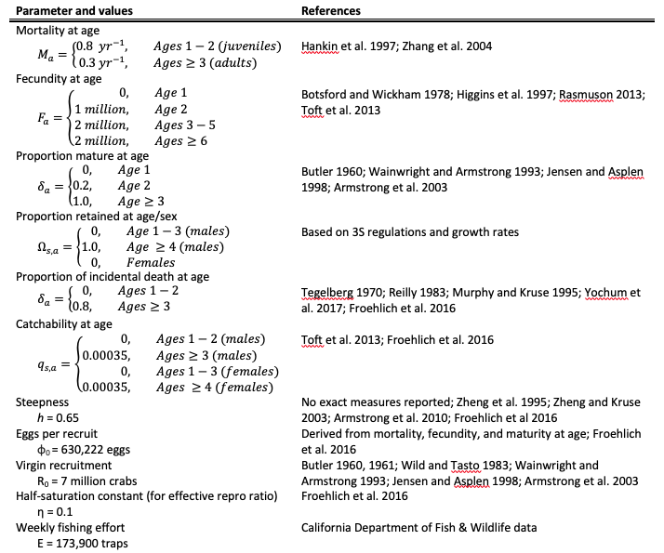

**Table 3.** Management strategies evaluated in our model.

Insert table.

1 The settlement also makes stipulations that do not directly affect the management of fishing effort including: (1) providing a stipend for Working Group members; (2) increasing opportunities for public engagement in the RAMP meetings; (3) supporting the development of whale species distribution models; and (4) supporting the development of ropeless gear technology.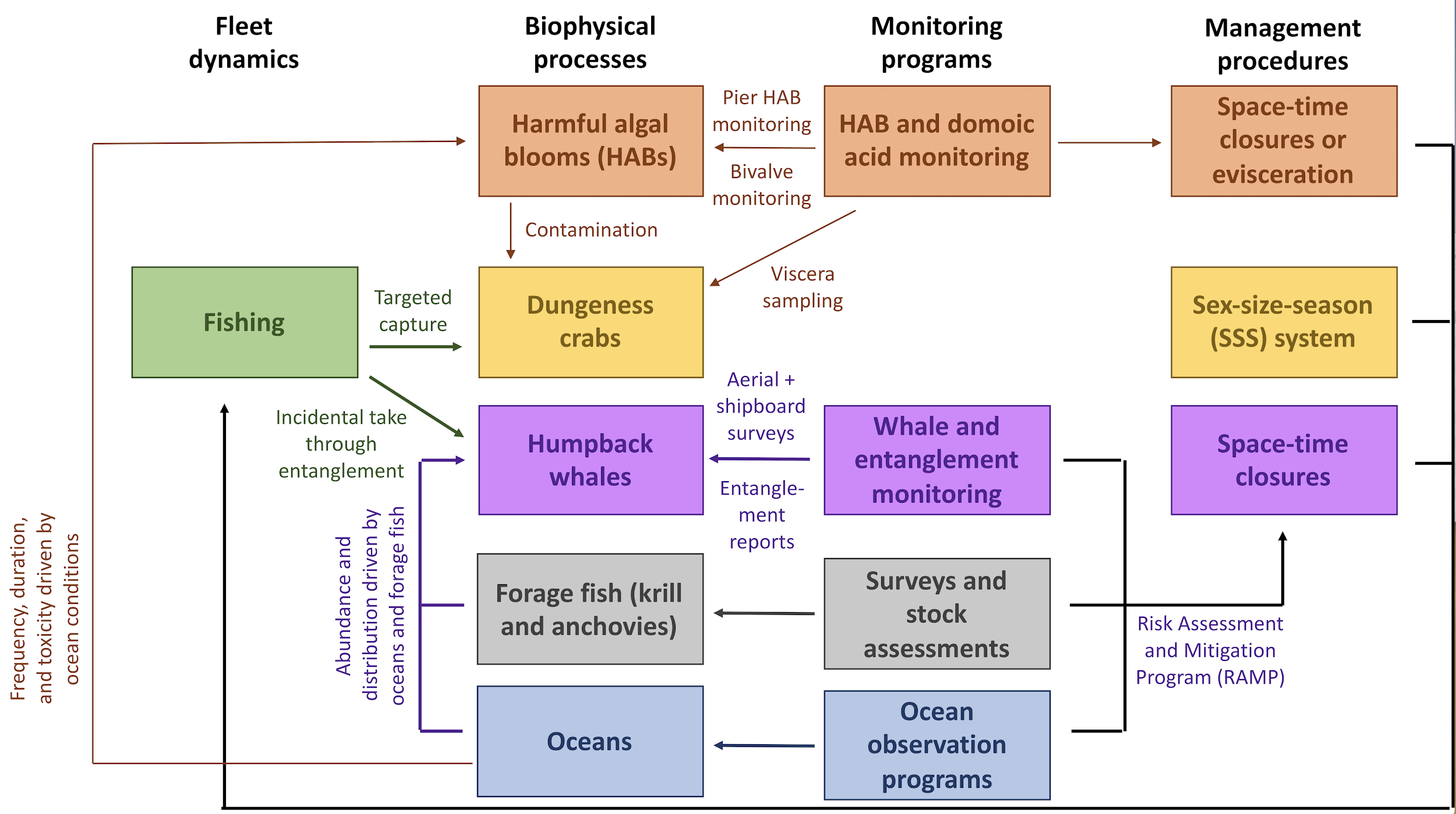

**Figure 1.** Structure of the management strategy evaluation model.

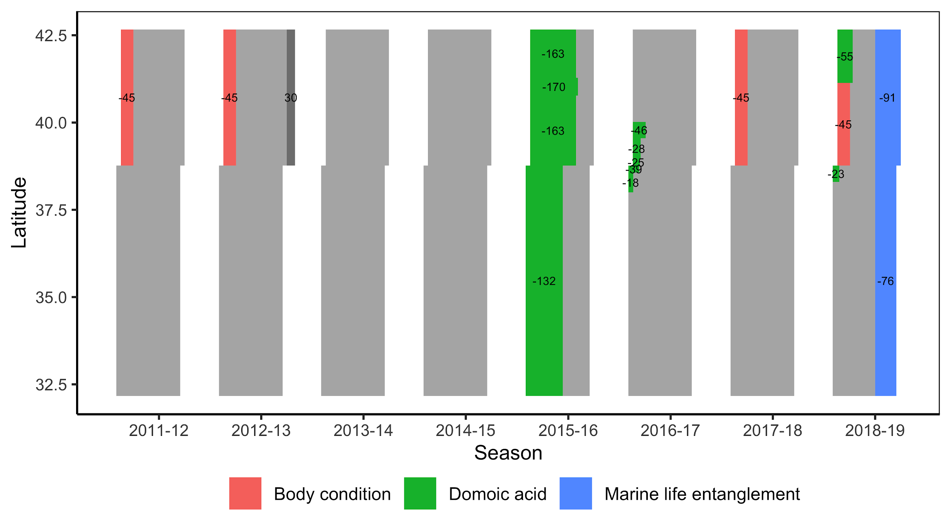

**Figure 1.** Timeline of closures resulting from low preseason meat quality, domoic acid contamination, or marine life entanglements from 2012-2019. The light grey rectangles show the regular Dungeness crab fishing season (Central: Nov 15-Jun 30, 228 days; Northern: Dec 1-Jul 15; 227 days).

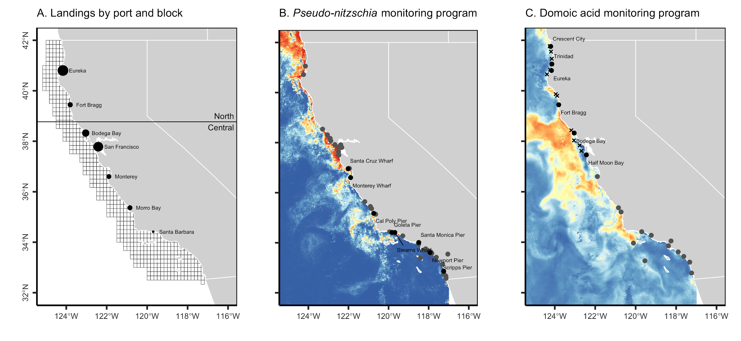**Figure 2.** Panel **(A)** shows the distribution of catch by block and by port (2014-18 mean). The initial distribution of crabs among blocks is proportional to the mean catch. Panel (**B**) shows C-HARM’s *Pseudo-nitzschia* bloom risk prediction map for July 1, 2015 and the network of quantitative (n=8 piers, black points) and qualitative (n=40 locations, grey points) monitoring sites. Panel (**C**) shows C-HARM’s cellular domoic acid risk prediction map for July 1, 2015 and the network of routine preseason (n=6 ports, black points, and 12 locations, black x’s) and ad-hoc mid-season (n=13 ports, grey points) monitoring sites for domoic acid in Dungeness crabs. Domoic acid concentrations are also measured at the eight piers shown in black in Panel **(B)**.

Things to do:

1. Add legends (with sample sizes for Panels B and C)
2. Reduce white space between plots
3. Generally enlarge font size
4. Panels B & C: Show a single day or a season average? Which day? Which season?

### Supplemental Tables & Figures

**Table S1.** Performance metrics for candidate models for estimating the probability that a crab is contaminated above or below the management action threshold (>30 ppm domoic acid) based on each of the previous 30 days of pDA risk estimated by C-HARM.

|  |  |  |  |
| --- | --- | --- | --- |
| **Method** | **Accuracy** | **Kappa** | **AUC** |
| Random forests | 0.84 | 0.43 | 0.80 |
| Boosted regression trees | 0.83 | 0.36 | 0.78 |
| Logistic regression | 0.80 | 0.15 | 0.64 |

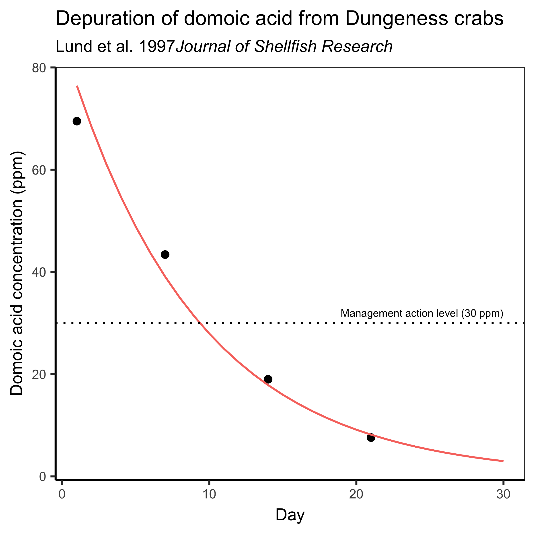

**Figure S1**. Depuration rate of domoic acid from Dungeness crab tissue based on laboratory experiments by Lund et al. 1997.

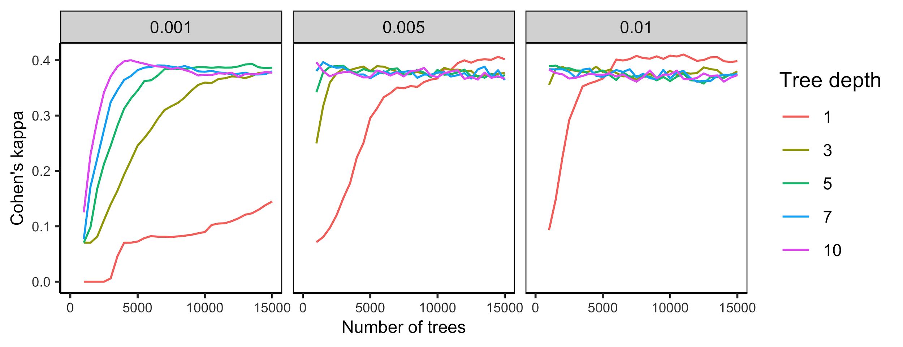**Figure S2.** Model tuning curves for the boosted regression tree model. Plots show mean Cohen’s kappa, a measure of model accuracy, for each combination of candidate parameters: learning rate (a.k.a., shrinkage), tree depth (a.k.a., interaction depth), and number of trees.

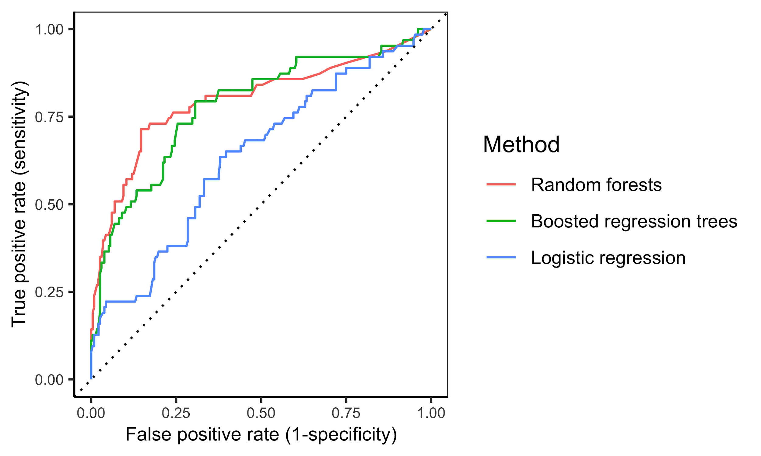

**Figure S3.** Receiver operating characteristic (ROC) curves for logistic regression, random forest, and boosted regression tree models that estimate the probability that a crab is contaminated above or below the management action threshold (>30 ppm domoic acid) based on each of the previous 30 days of pDA risk estimated by C-HARM. The random forest model exhibited the largest area under the curve (AUC) and was selected as the final model.

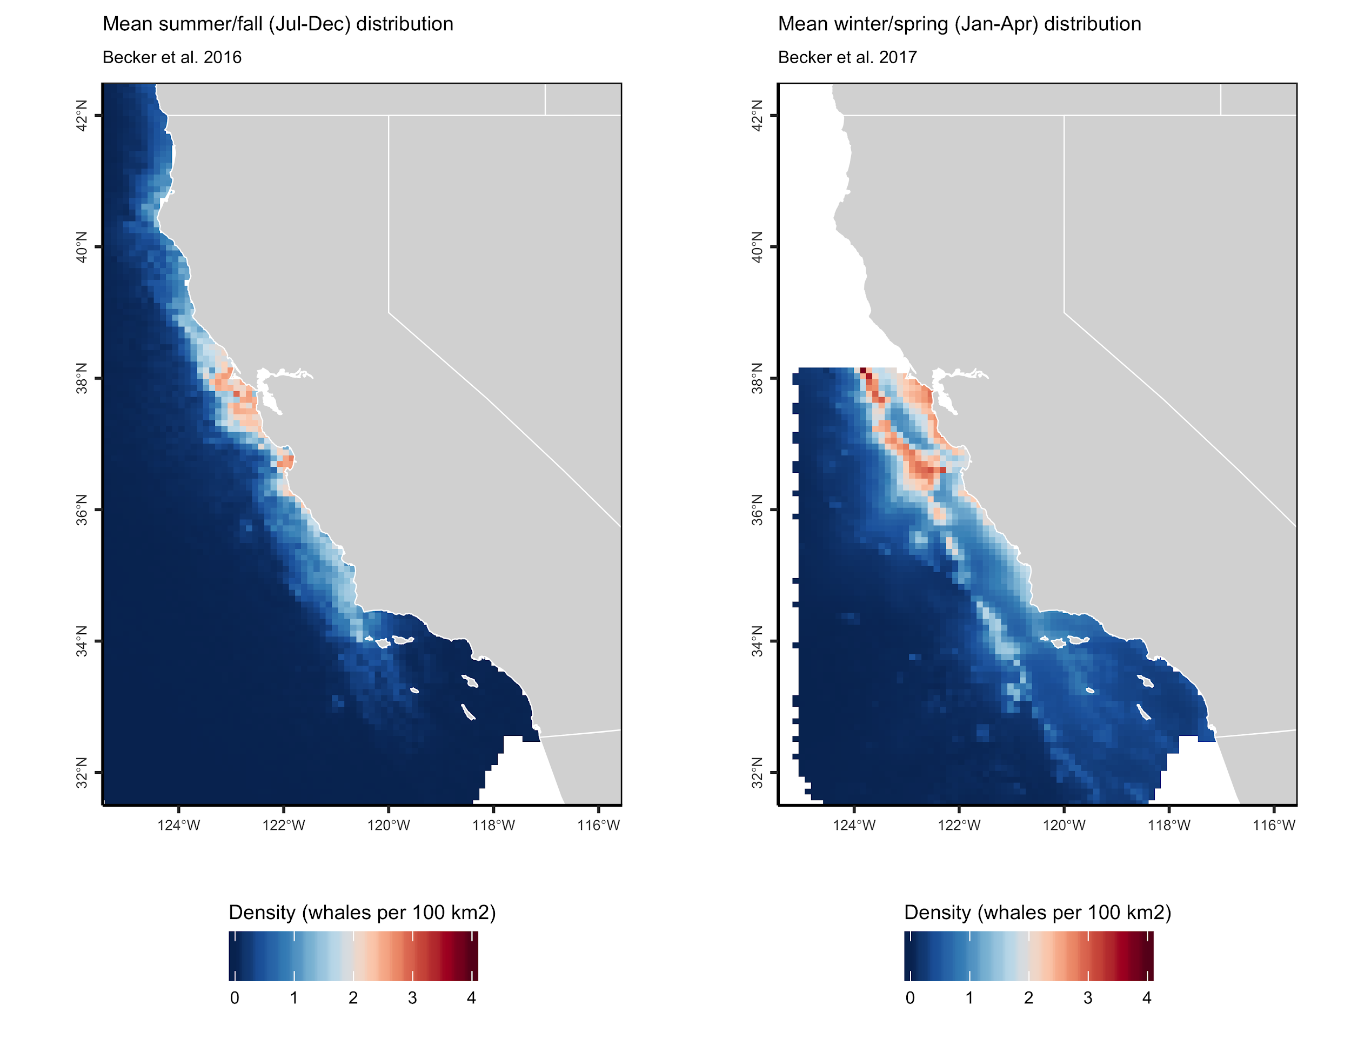**Figure S4.** Mean **(A)** summer/fall and **(B)** winter/spring humpback whale distributions along the California coast based on Becker et al. (2016) and Becker et al. (2017), respectively.

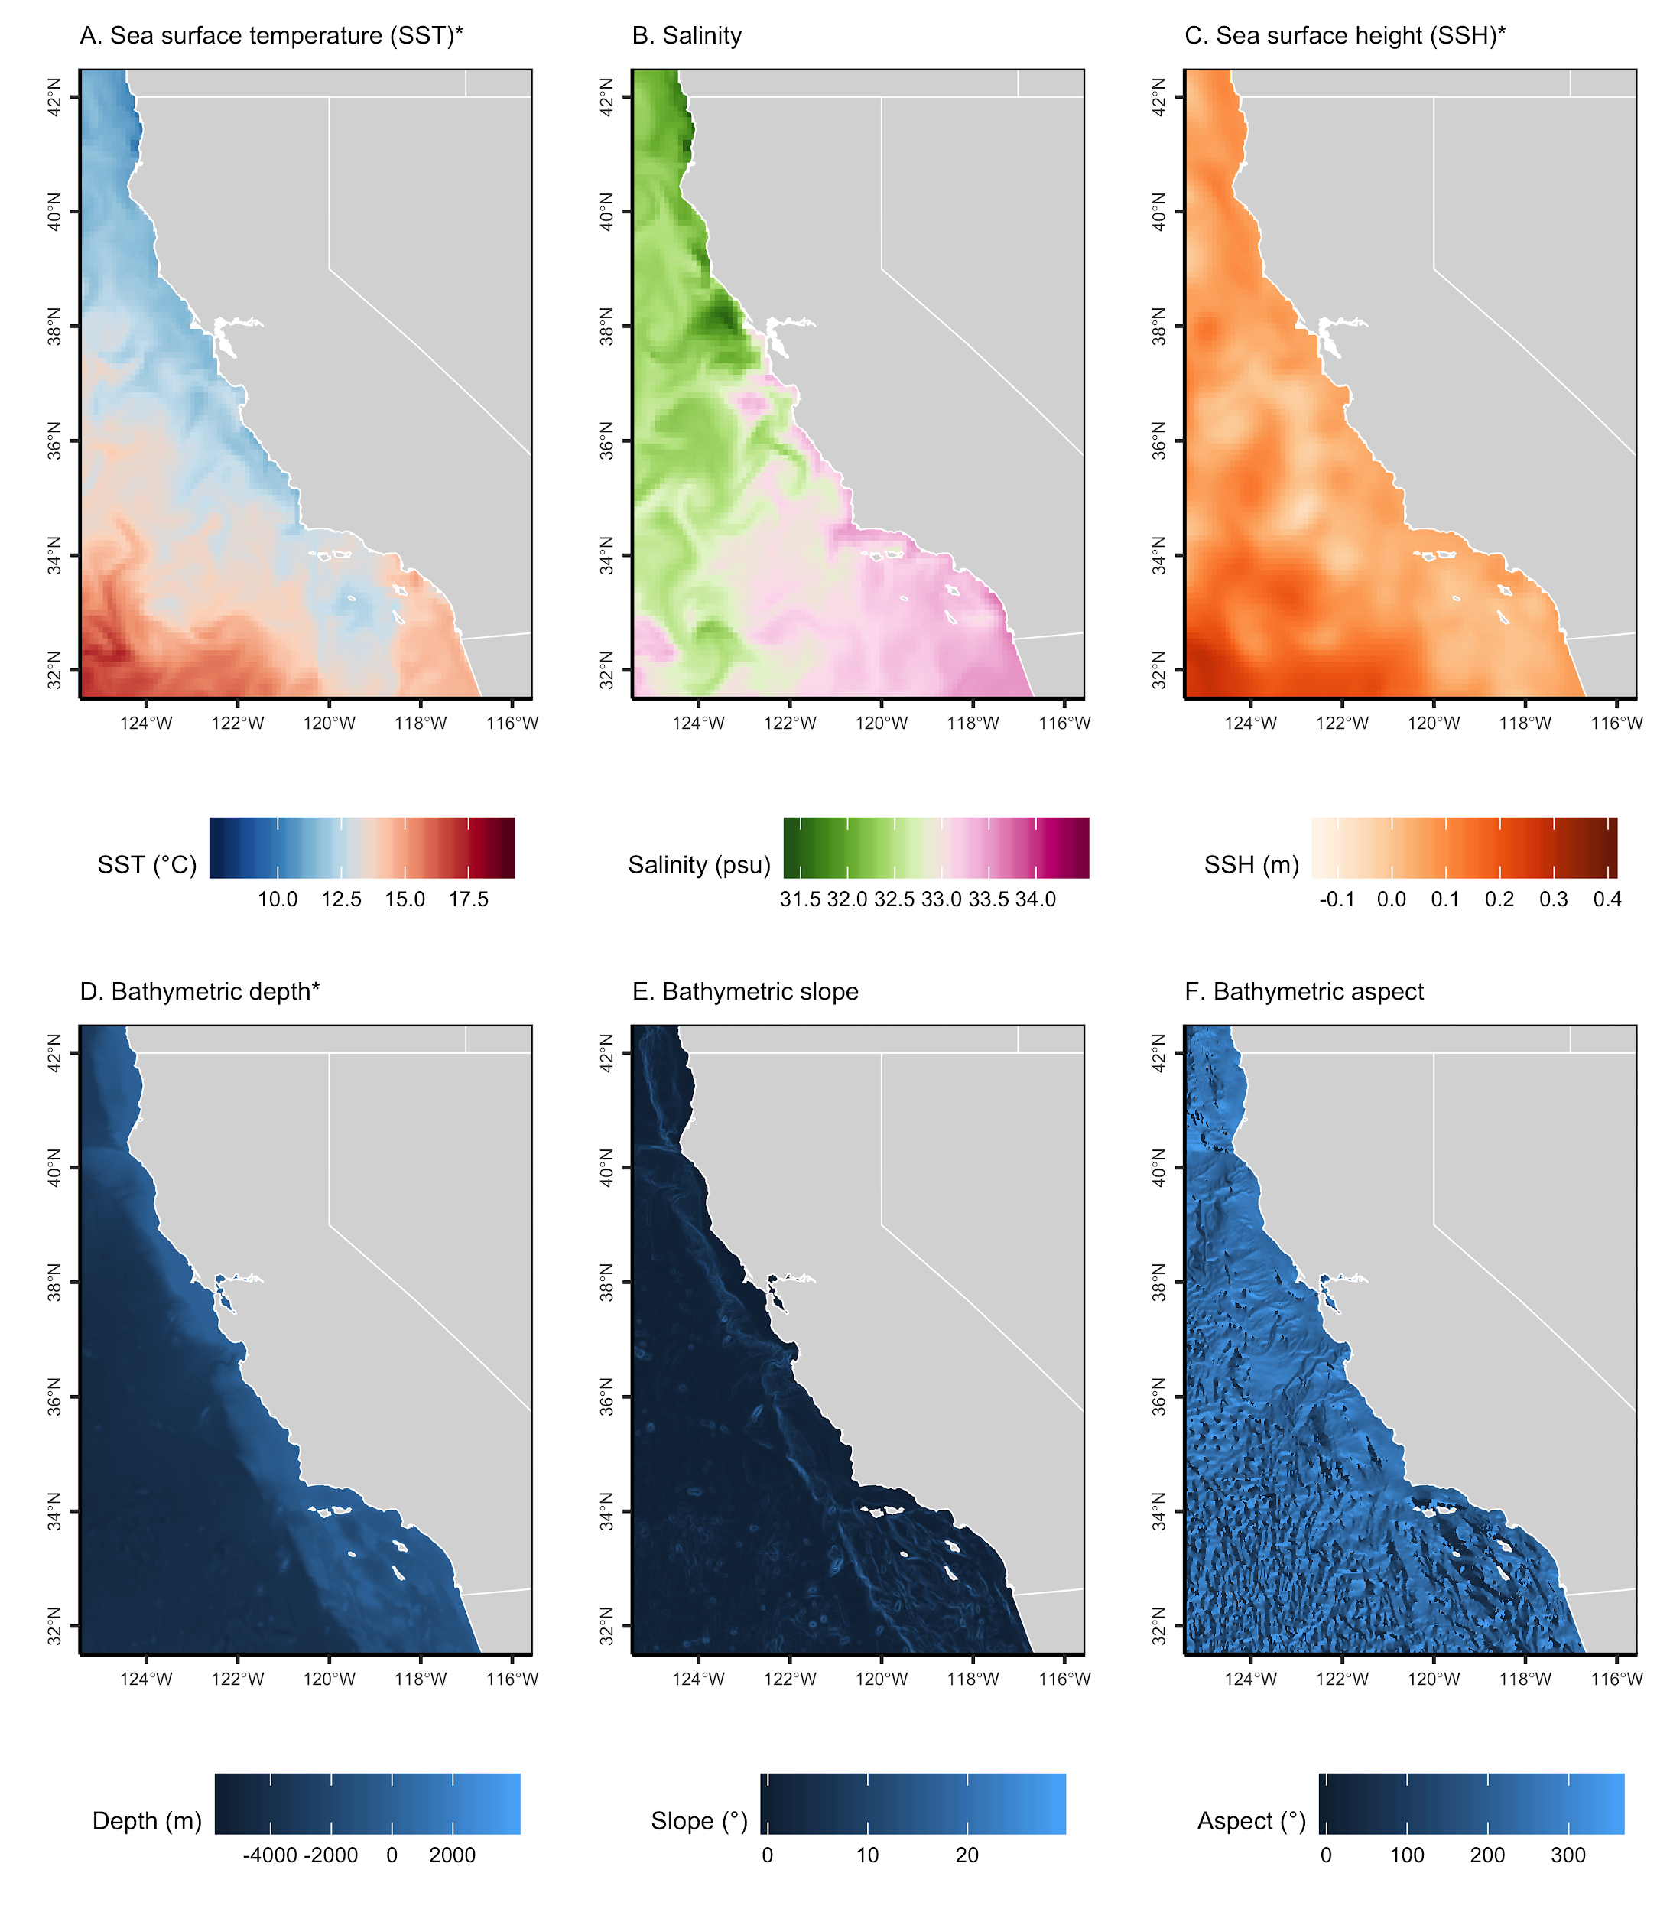

**Figure S5.** Habitat variables used in the whale distribution models. Dynamic ocean variables from the California ROMS model (Moore et al. 2011) are: **(A)** sea surface temperature (SST, °C at 5-m depth); **(B)** salinity (psu at 5-m depth); **(C)** sea surface height (SSH, m; standard deviation of SSH was also used but is not shown here). Static variables derived from the ETOPO1 Global Relief model (Amante and Eakins 2009) are: bathymetric **(D)** depth (m); **(E)** slope (°); and **(F)** aspect (°). All of the pictured variables are used in the summer/fall model (Becker et al. 2016) and only the starred (*) variables are used in the winter/spring model (Becker et al. 2017).

Improvements: (1) Add potential energy anomaly; (2) Make date of dynamic data clear and plot associated whale distribution; (3) Perfect color bars.

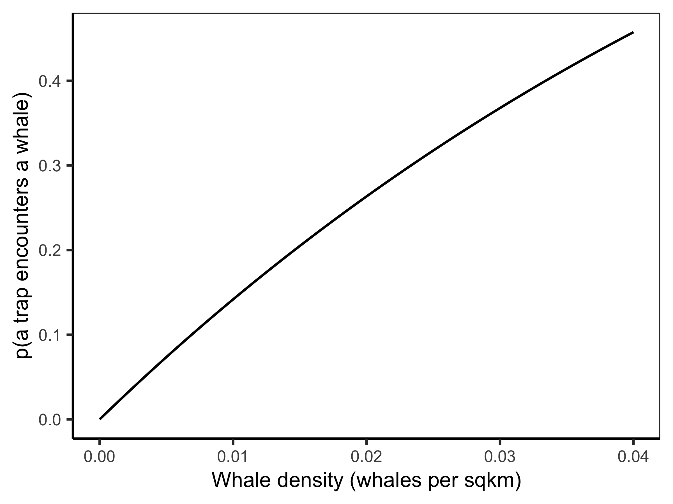

**Figure S6.** The probability that a crab trap encounters a humpback whale in areas of increasing whale density. This probability is derived based on the random movement of particles in ideal gas theory (Rowcliffe et al. 2003; Hutchinson & Waser 2007) and is a function of whale density, whale speed, risky passing distance, and time duration.

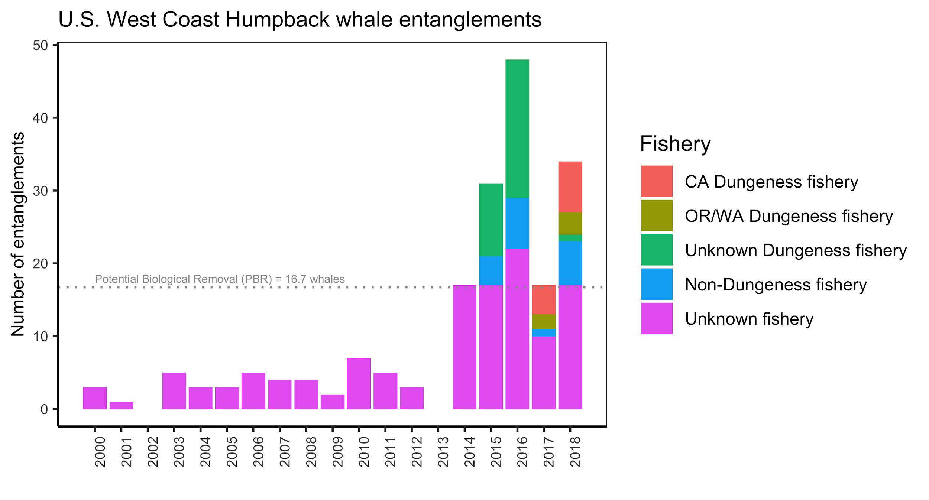**Figure S7.** Confirmed humpback whale entanglements from 2000-2018 by fishery. The 2000-2014 data was extracted from a figure in the 2018 entanglement report (NOAA 2018) using WebPlotDigitizer (<https://automeris.io/WebPlotDigitizer/>). The 2015-2018 data was extracted from tables in the 2015-2018 entanglement reports (NOAA 2015, 2016, 2017, 2018). Note that not all entanglements result in mortality or serious injury (Carretta et al. 2018).

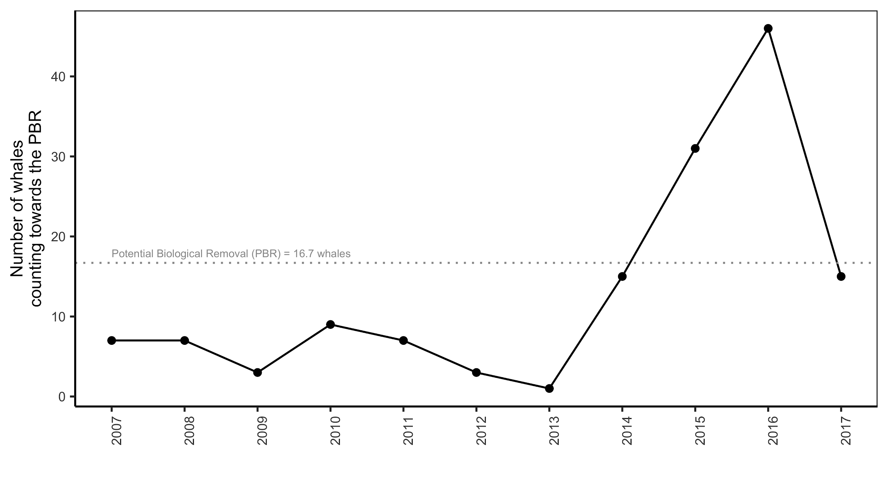

**Figure S8.** Number of whales counting towards the potential biological removal (PBR).

### 

### Supplemental Methods

#### Contamination model development

We simulated the contamination of Dungeness crabs by developing a model that relates C-HARM’s predictions of pDA risk to the domoic acid concentrations of Dungeness crabs sampled by the California Department of Public Health (CDPH) as part of its biotoxin monitoring program. The CDPH sampled 1,481 crab viscera from locatations coastwide from July 2015 to January 2016 including 318 crabs (21% of sampled crabs) with domoic acid concentrations above the 30 ppm management action threshold. We used 80% of this data (n=1,186 crabs) for model development and the remaining 20% (n=295 crabs) for model testing.

We evaluated the ability of three classification models -- logistic regression, random forest, and boosted regression trees -- to estimate the probability that a crab is contaminated above the management action threshold based on each of the previous 30 days of pDA risk. We considered 30 days of pDA risk given laboratory experiments showing that contaminated crabs took 21 days to depure 89% of their initial domoic acid load (Lund et al. 1997; **Figure S1**). C-HARM pDA predictions were unavailable for X% of days and missing values were kNN imputed using the three nearest neighbors. For both the random forest and boosted regression tree models, we performed grid searches for the tuning parameter combinations that maximize Cohen’s kappa using repeated 10-fold cross validation (**Figure S2**). The models were fit using a combination of the *tidymodels* (Kuhn & Wickham 2019), *caret* (Kuhn 2019), *gbm* (Greenwell et al. 2019), and *randForest* (Liaw et al. 2018) packages in R (R Core Team 2019).

We measured model performance in terms of accuracy, Cohen’s kappa, and the area under the receiver operating characteristic curve. Accuracy measures the proportion of correct classifications. Cohen’s kappa measures the proportion of correct classifications accounting for the probability of being correct by chance (Cohen 1968). Although there are no definitive rules for interpreting Cohen’s kappa, general guidelines suggest that values >0.70 are ‘excellent’, 0.4–0.7 are ‘good’, 0.2–0.4 are ‘fair’, and <0.2 are ‘poor’ (Landis and Koch 1977; Fleiss 1973). The receiver operating characteristic (ROC) curve depicts classification performance by plotting the true positive rate (probability of detection) against the false positive rate (probability of false alarm) at various threshold settings. The area under the curve (AUC) thus measures how well a classifier can distinguish between two groups (i.e., contaminated vs. uncontaminated) where 1.0 means the classifier is perfect and 0.5 means a classifier is no better than a coin flip.

#### CBD vs. Bonham settlement stipulations

The settlement requires that the CDFW submit a Habitat Conservation Plan (HCP) to NOAA by May 15, 2020 in order to apply for an Incidental Take Permit (ITP). The settlement then specifies interim management measures to be used until the HCP is approved and the ITP is issued. It allows for different approaches to replace these interim measures if the CDFW can demonstrate that they are as effective using best available science.

First, the Working Group will meet twelve times a year (once a month before Mar 15 and twice a month after Mar 15) to assess entanglement risk and recommend management actions following an updated RAMP procedure: Nov 1, Dec 15, Jan 15, Feb 15, Mar 15, Apr 1, Apr 15, May 1, May 15, Jun 1, Jun 15, Jul 1.

Second, the risk of whale entanglement will be assessed using two sets of risk factors: (1) a set where just one risk factor demonstrates elevated risk and triggers management action; and (2) a set where two or more risk factors demonstrate elevated risk and trigger management action. The risk factors that would individually indicate elevated risk are:

1. **Presence of species of concern:** This indicator is triggered by either the observation of a total of >20 whales in a single survey or average of >5 whales over one week of a survey in California waters. The settlement specifies that the eligible surveys are the NOAA fall aerial marine mammal survey and the NOAA spring shipboard rockfish survey. If elevated risk is triggered based on the fall aerial survey, the risk will remain elevated through Dec 15. If triggered based on the spring rockfish survey, it will remain elevated the remainder of the season.
2. **Number of confirmed ESA-listed entanglement:** This indicator is triggered when there are >=1 confirmed entanglements of an ESA-listed species during the fishing season. A confirmed entanglement CA Dungeness crab commercial fishing gear counts as 1.0 entanglements while a confirmed entanglement of an ESA-listed species in an unknown gear or an unknown species in CA Dungeness crab commercial fishing gear counts as 0.5 entanglements.

The risk factors that would indicate elevated risk in combination are:

1. **Fleet dynamics:** This indicator is triggered in (1) the first two weeks of any season and (2) any season opening after Feb 1.
2. **Ocean conditions:** This indicator is triggered when ocean or forage conditions are likely to result in increased overlap in whale distributions and crab fishing. This is considered likely to happen when at least two of the following are true: (1) upwelling is below average, which can be surmised when sea surface temperatures are warmer than average; (2) there is low offshore krill abundance and high inshore anchovy abundance based on stock assessments or surveys; and (3) whales are concentrated nearshore based on the NOAA fall marine mammal aerial or spring rockfish shipboard surveys.

Third, the settlement dictates that management actions in response to elevated risk will be (1) commensurate with the level of risk; (2) based on the best available science; (3) forward-looking and spatially explicit; and consistent with Fish & Game Code 8276.l (c)(3). The settlement proposes the following possible management actions (1) modification of fishing season and allowable fishing areas (i.e., space-time closures); (3) spatially explicit trap limits (total or per-vessel); (3) requirement of specialized gear (e.g., ropeless gear); or (4) no action. Management actions can be removed once there is no longer an elevated entanglement risk.

Fourth, the settlement requires that (1) the 2019-20 season closes April 1 for Districts 10, 17, and south unless the March 15 risk assessment indicates low risk of entanglement and (2) the 2020-21 season and every season thereafter, Districts 10, 17, and south are only open to ropeless fishing gear after April 1 unless the March 15 risk assessment indicates low risk of entanglement.

Finally, the settlement makes a series of stipulations that do not directly affect the management of fishing effort including: (1) providing a stipend for Working Group members; (2) increasing opportunities for public engagement in the RAMP meetings; (3) supporting the development of whale species distribution models; (4) supporting the development of ropeless gear technology; (5) supporting the development and use of solar loggers for tracking vessel locations; and (6) requiring the marking of all fixed gear fisheries gear.